Appendix A
Tables and Figures
Tables
Table A1. Participant Information
Year | # of scholars | Grade range | Average years in GSI
2023 | 33 | 3 -10 | 2
2024 | 39 | 3 -11 | 2
2025 | 38 | 3 -12 | 3

Table A2. Overview of Girls STEM Institute Program Components and Intended Outcomes
Program Theme (STC 5Cs addressed and Communal Goal Construct) | Learning Experiences | Intended Outcomes
Aviation: Past, Present, and Future (Content, Context, Currency, Critique and Connections with Others, Collaboration, and Prosocial Actions) | Scholars explored the contributions of historical and contemporary Black women in aviation; learned about aviation careers (pilot, maintenance, dispatcher, flight attendant, crew scheduler, administration); studied basic flight physics; built remote-controlled aircraft; and participated in flight simulations. | Support scholars in envisioning themselves as future aviators while developing foundational STEM knowledge and career awareness.
Robotics (Content, Context, Currency, Critique and Collaboration, Prosocial Actions, and Interpersonal Connections) | Scholars engaged in an age appropriate VEX robotics curriculum that integrated multiple STEM domains and emphasized how robotics can address community needs. | Foster interdisciplinary STEM thinking and promote problem-solving connected to real-world and community contexts.
Mathematics of Financial Wellness (Content, Context, Currency, Critique, Conduct and Prosocial Actions and Caring Roles) | Scholars participated in a financial simulation exploring wealth disparities and financial decision-making through algebraic reasoning. | Develop mathematical thinking while building awareness of financial systems and equity-related issues.
Science of Wellness (Content, Context, Currency, Critique and Prosocial Actions and Interpersonal Connections) | Scholars explored careers in medical and wellness-related fields; participated in mindfulness sessions; and engaged in physical fitness activities, including African dance. | Promote holistic well-being while connecting STEM learning to health, identity, and personal empowerment.

Appendix A (continued)
Table A3. Internal consistency values for Career Interest Questionnaire
Subscales | Pre Omega (ω) | Post Omega (ω)
Career Interest & Family Support (items 1-4) | .82 | .86
Career Confidence and Goals (items 5-9) | .87 | .94
Perceived Value & Social Meaning of Science Careers (items 10-13) | .73 | .73

Note: ω = McDonald’s omega reliability coefficient. Values ≥ .70 indicate acceptable internal consistency.
Table A4. Pooled results for dependent-samples t-test for Career Interest Survey
Factor | Δ Mean | SE | df | Pooled t | p-value | Missing Info (%)
Career Interest & Family Support | -0.04 | 0.09 | 453.93 | -0.37 | 0.65 | 10%
Career Confidence & Goals | 0.22 | 0.10 | 65.41 | 0.19 | 0.43 | 22%
Perceived Value & Social Meaning of Science Careers | 0.25 | 0.09 | 46.07 | 3.87 | 0.0002 | 43%

Table A5. Pooled results for dependent-samples t-test for Career Interest Survey by item
Item | Δ Mean | SE | Pooled t | df | p-value
Item 1 | 0.10 | 0.13 | 0.78 | 259.98 | 0.22
Item 2 | -0.14 | 0.14 | -1.00 | 2349.61 | 0.84
Item 3 | -0.09 | 0.16 | -0.59 | 85.71 | 0.72
Item 4 | -0.01 | 0.14 | -0.07 | 121.68 | 0.53
Item 5 | 0.13 | 0.16 | 0.81 | 43.34 | 0.21
Item 6 | 0.02 | 0.16 | 0.10 | 112.34 | 0.46
Item 7 | -0.08 | 0.14 | -0.59 | 554.21 | 0.72
Item 8 | 0.50 | 0.16 | 3.23 | 69.53 | p < .001**
Item 9 | 0.52 | 0.16 | 3.37 | 163.48 | p < .001**
Item 10 | 0.63 | 0.17 | 3.62 | 189.28 | p < .001**
Item 11 | 0.35 | 0.16 | 2.22 | 116.10 | 0.01*
Item 12 | 0.05 | 0.15 | 0.37 | 163.18 | 0.36
Item 13 | -0.04 | 0.16 | -0.24 | 29.34 | 0.59

Appendix A (continued)

Figures
Figure A1. Pillars of Girls STEM Institute
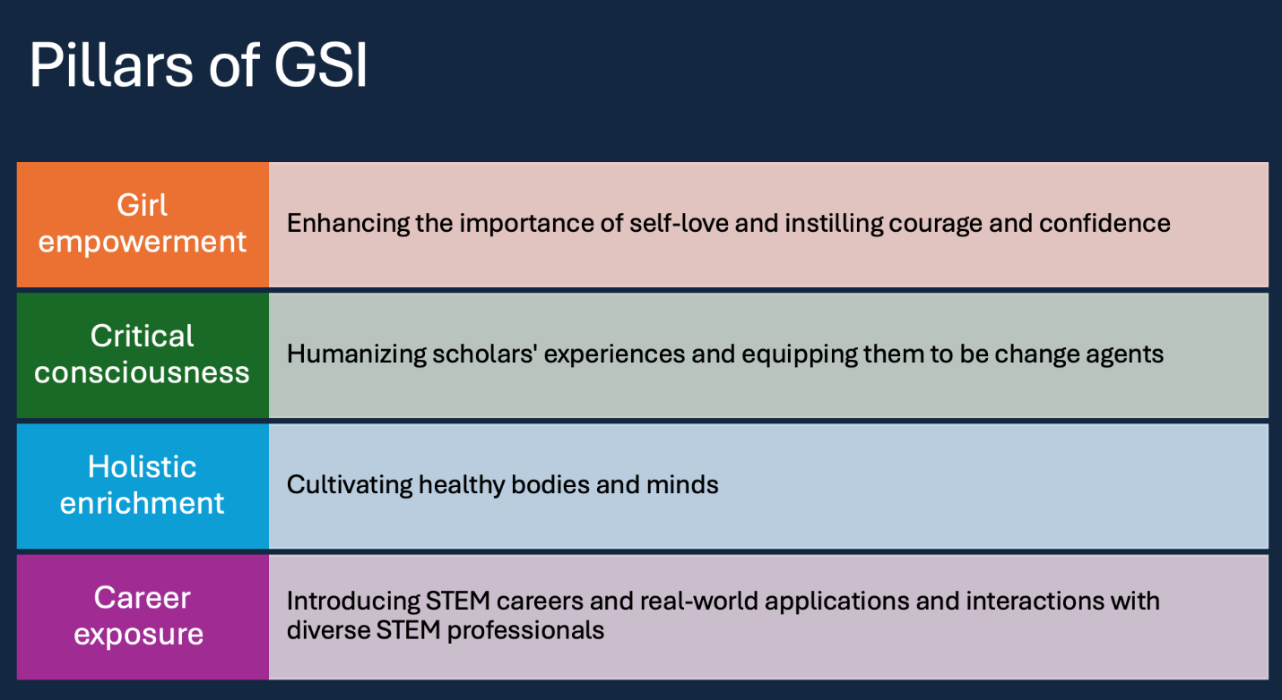

Appendix A (continued)

Figure A2. Sample Interview-Scholar Dialogue

